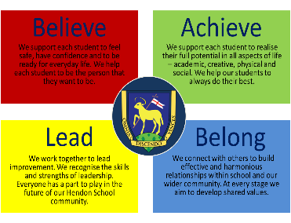
Hendon School Sixth Form
(HS6)
External Student Application Form

PERSONAL INFORMATION
Surname | Date of Birth
First Name(s) | Gender
Address  Postcode | Nationality on Passport
 | Ethnicity
 | Main home language
 | Student Mobile no.
 | Student Home no.
 | Email (in capital letters)

Present School
School Referee Mr Mrs Miss Ms  First Name | School Name
Surname | School contact number
Position | Referee’s email (in capital letters)
School Address

Postcode

HS6 Option Choices
Please refer to the HS6 entry requirements

Please choose 1 of the 3 pathways below taking into consideration predicted grades and the HS6 entry criteria.
Pathway 1: A Level Courses and Level 3 Technical. Choose 4 subjects and a reserve choice.
Choice 1
Choice 2
Choice 3
Choice 4
Reserve choice

Pathway 2: Level 3 Technical Courses. Choose 3 subjects and a reserve choice.
Choice 1
Choice 2
Choice 3
Reserve choice

Pathway 3: Level 2 Technical (including Employability Skills). Tick 2 subjects below.
Business □ ICT □
Health and Social Care □ T&T □

Tick Maths / English if your predicted grade is 3 or below

GCSE Maths retake □ | GCSE English retake □

List your reasons for choosing Hendon School 6th Form and why you think you are suitable for the course chosen.

HS6 Academic Reference

Referee to complete the following information for: Name_______________________________________
To be completed by Applicant  Add additional subjects | To be completed by applicant’s referee
All Examinations Entered | Target Grade e.g. FFT | Teacher Grade
English Language
English Literature
Mathematics
Science
Attendance %

UPN No.
To be completed by applicant’s referee | E  x  c  e  l  l  e  n  t | G  o  o  d | A  v  e  r  a  g  e | P  o  o  r
Punctuality
Behaviour
Commitment to learning
Ability to work independently
Ability to meet deadlines
Relationship with staff
Relationship with peers

Referee school reference. Please use this space to include comments on the suitability of the applicant for the courses chosen.

Has this student been excluded from school in the last 2 years? | Yes  If yes, please attach details | No
Does this student have a statement of Educational needs? | Yes  If yes, please attach details | No
Does this student have special access arrangements for examinations? | Yes  If yes, please attach details | No
Has this student ever been subject to a CP care plan or been a child in need? | Yes  If yes, you will be asked for details before entry | No

Referee | School stamp
Signature
Position
Date

Return HS6 Application form to:
Ms Tuac and Ms Pelen, Sixth Form
Hendon School, Golders Rise, Hendon NW4 2HP
HS6admissions@hendonschool.co.uk

