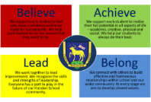

Hendon School Formal Complaint Form

Please email completed form to Karen Goodall – Goodallk@hendonschool.co.uk

Name:
Student/Staff name:
Students form:
Date:
Your complaint:
Action you have taken so far:

What has the school’s response been:
Why are you not satisfied:

